Asa Hayes GEOG-312 4 March, 2021

**GEOG-312: Lab 4 – Spatial Sampling**

I selected (by random number generator) the Simple Random and Stratified Random sampling methods. Random.org was used for all generations.

Simple Random Sample: First, I used a random number generator to choose 5/20 (25%) of the larger areas (38-57). Then within each of those blocks, I used the random number generator to choose 5 sub-blocks, which I then drew polygons for.

Large blocks selected: 57, 47, 48, 40, 54

57: 19, 10, 8, 17, 24

47: 16, 3, 2, 25, 14

48: 8, 3, 20, 5, 7

40: 15, 8, 6, 22, 23

54: 25, 22, 15, 13, 20

Note: Even with area color changed to purple, visibility at a wider scale than depicted is limited.

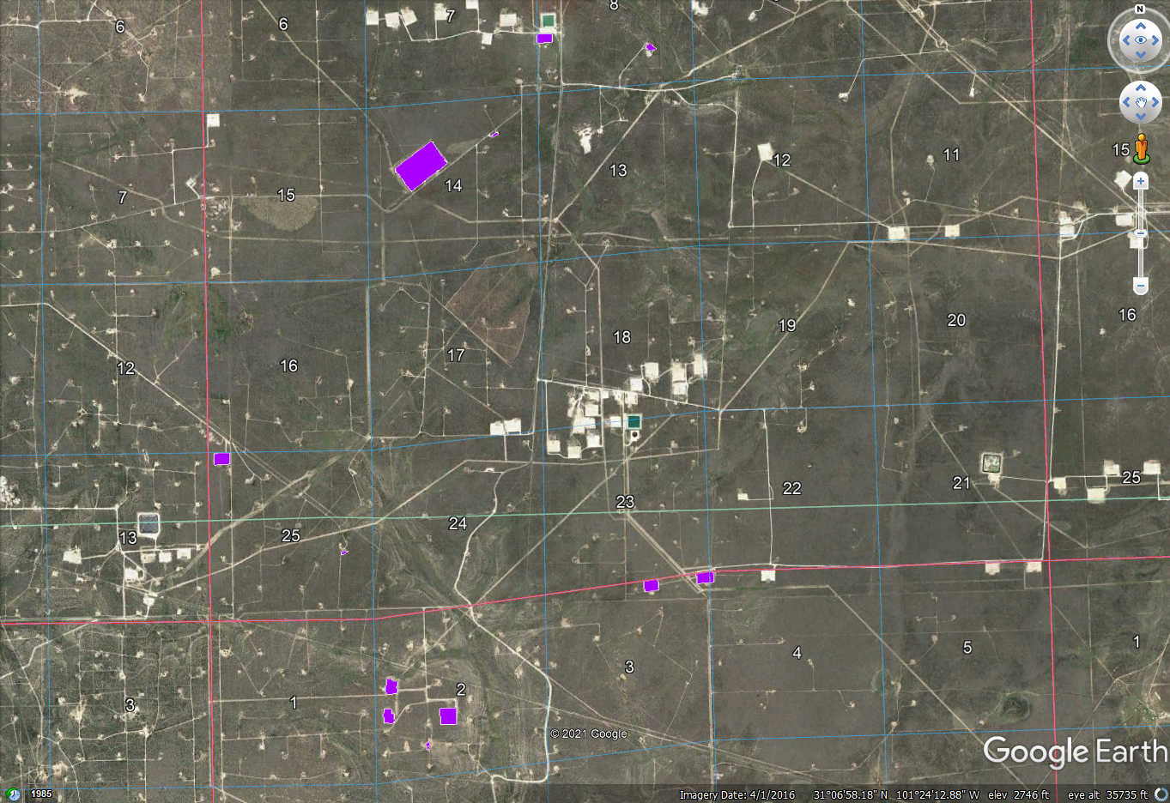

Stratified Random Sample: For this approach, we would need to cover all the larger blocks, and do a random sample within each larger block/strata. The procedure would essentially be the same as above, but all large blocks are covered instead of 5 randomly selected ones and with 2 small blocks per large block instead of 5. Reducing the samples per large block to 2 will keep the amount of measurements closer in scope to the amount in the Simple Random Sample.

38: 1, 6; 39: 26, 1; 40: 10, 3; 41: 16, 15; 42: 19, 9; 43: 9, 19; 44: 2, 9; 45: 9, 21; 46: 11, 20

47: 3, 16; 48: 16, 5; 49: 8, 15; 50: 13, 10; 51: 12, 7; 52: 5, 14; 53: 24, 16; 54: 3, 1; 55: 14, 4

56: 13, 16; 57: 4, 25

Note: Like previous screenshot, even brightening the area would not allow for full display at extent of entire area of study. Data should still be sound as collected in KML file.

